Satellite Detumbling Project

Problem statement:

A spacecraft is deployed from a rocket in Low Earth Orbit with an initial body rate of $ω =\left[\begin{aligned}ω_{xo} \\ ω_{yo} \\ ω_{zo}\end{aligned}\right]$. Ground station sends a signal to the spacecraft to enter safe mode. That is, the spacecraft is commanded to stop tumbling $(ω_{des} =\left[\begin{aligned}0 \\ 0 \\ 0\end{aligned}\right]rad/s)$ within one orbit (~90minutes). The spacecraft is using momentum wheels which saturate at |Mmax | = 5Nm. Ground station wants to use as little battery reserve power as possible. Design a controller (e.g. PID, LQR, etc.) to detumble the spacecraft given that:

$$ω_{0} =\left[\begin{aligned}4 \\ -3 \\ 5\end{aligned}\right]rad/s$$

$$\vec{I}spacecraft =\left[\begin{matrix}I_{xx}=100 & 0 & 0 \\ 0 & I_{yy}=100 & 0 \\ 0 & 0 & I_{zz}=1,000\end{matrix}\right]$$

Analysis of effectiveness of solution:

Strategy:

The team implemented PID control to more effectively stabilize the spacecraft. A Simulink model was produced to simulate the out of control spacecraft and the reaction wheel setup being used to control the system. The angular accelerations can be described with the following differential equations,

$${\dot{w}}_{1}= \frac{1}{I_{1}}*\left[M_{1}+ w_{2}w_{3}\left(I_{2}- I_{3}\right)\right]$$

$${\dot{w}}_{2}= \frac{1}{I_{2}}*\left[M_{2}+ w_{1}w_{3}\left(I_{3}- I_{1}\right)\right]$$

$${\dot{w}}_{3}= \frac{1}{I_{3}}*\left[M_{3}+ w_{1}w_{2}\left(I_{1}- I_{2}\right)\right]$$

These values can then be integrated to give the angular velocities, and the initial conditions for velocity from the problem statement are applied in these blocks. The error being fed back to the PID blocks is the desired angular velocity (w = 0) minus the current angular velocities. In other words, the error being fed back is the negative of the current measured velocities. This results in a large expression with nine PID constants for each axis and to simplify this the errors stemming from the other axes are ignored. This leaves the following equations for M1, M2, and M3 where e is negative of the current angular velocity.

$$M_{1}= K_{P1}e_{1}+ K_{I1}\int{e_{1}dt}+ K_{D1}{\dot{e}}_{1}$$

$$M_{2}= K_{P2}e_{2}+ K_{I2}\int{e_{2}dt}+ K_{D2}{\dot{e}}_{2}$$

$$M_{3}= K_{P3}e_{3}+ K_{I3}\int{e_{3}dt}+ K_{D3}{\dot{e}}_{3}$$

In order to quantify the cost of our solution, the moments were summed and their absolute values are integrated to produce total control effort. Total control effort should be minimized along with time. Once the model was setup as shown below, the controller gains could be determined.

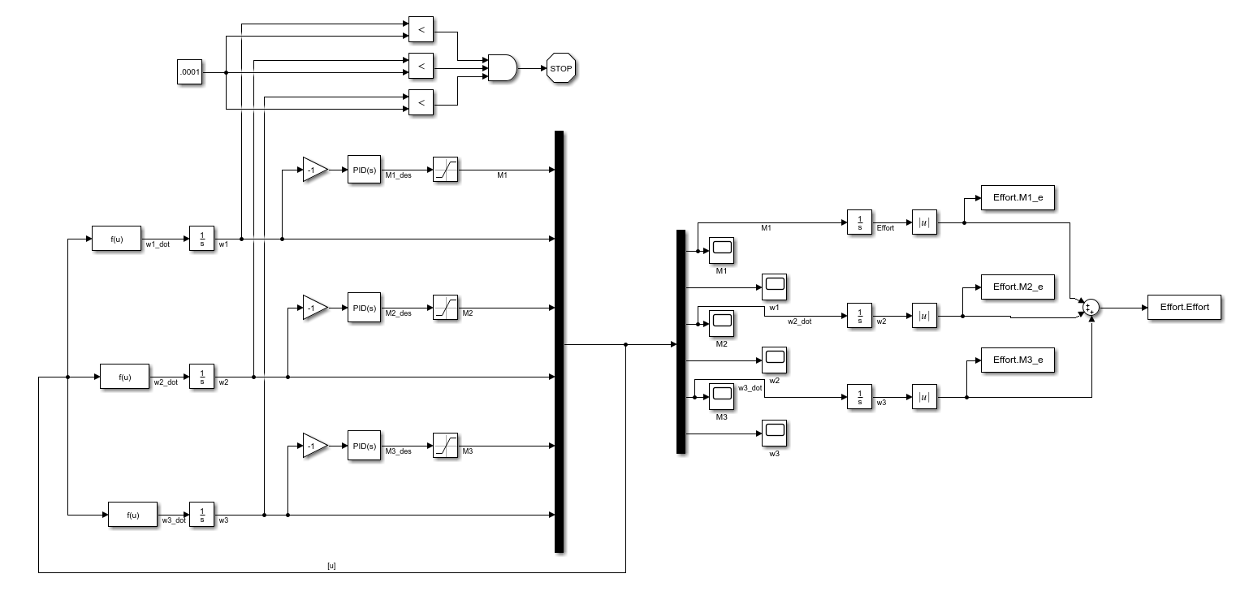

Figure Simulink Map

The PID gains were left variable to be changed iteratively to “tune” the gains to produce the desired output. Starting from all ones, the gain values were slightly changed, and their corresponding outputs closely monitored until everything stabilized in enough time. This method may seem simple, but it is commonly used as simpler simulations s`uch as these do not require much run time, so iterative guess and check problem solving is a valid approach.

For situations requiring more sophisticated simulation, one might use numerical optimization to target suitable values more quickly. To practice this approach, we created a cost function to narrow down on a value mathematically. MATLAB’s fmincon function is used to find minimums of a constrained nonlinear multivariable function. This is still an iterative method, but it allows for the program to be run continuously until certain parameters specified by the user are met.

Design Parameters:

The team was tasked with detumbling a spacecraft within one ninety-minute orbit, minimizing time and total effort was a secondary priority. This spacecraft held with it a few design parameters we must abide by and navigate around. Primarily, the momentum wheels must not exceed |Mmax| = 5Nm of torque. Initial momentum values of $I_{xx}=100 kg*m^{2},$ $I_{yy}=100 kg*m^{2}$, and $I_{zz}=1,000 kg*m^{2}$ were recorded. Initial body rates of $ω_{0} =\left[\begin{aligned}4 \\ -3 \\ 5\end{aligned}\right]rad/s$ and final body rate values of $ω_{des} =\left[\begin{aligned}0 \\ 0 \\ 0\end{aligned}\right]rad/s$. These parameters were met with initial conditions as stated in the problem statement.

Plots

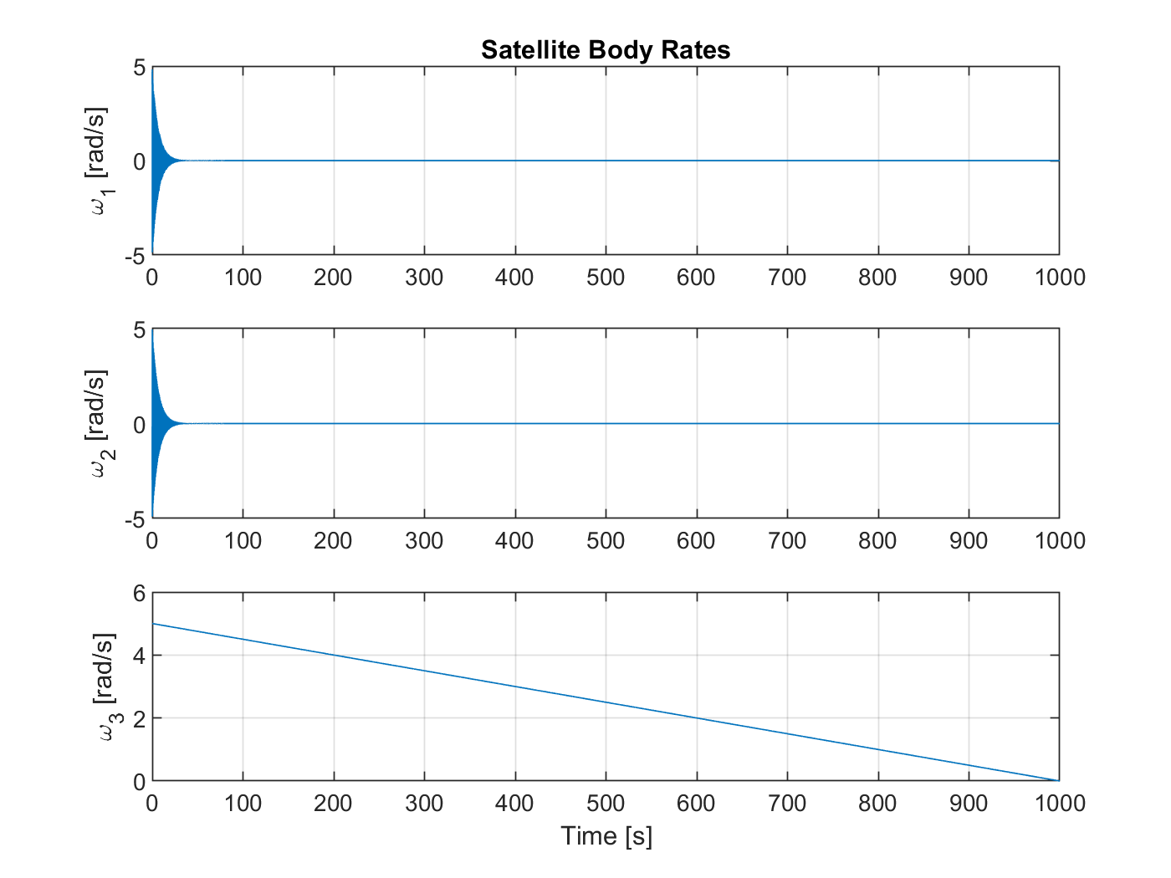

Figure Satellite Body Rate vs Time

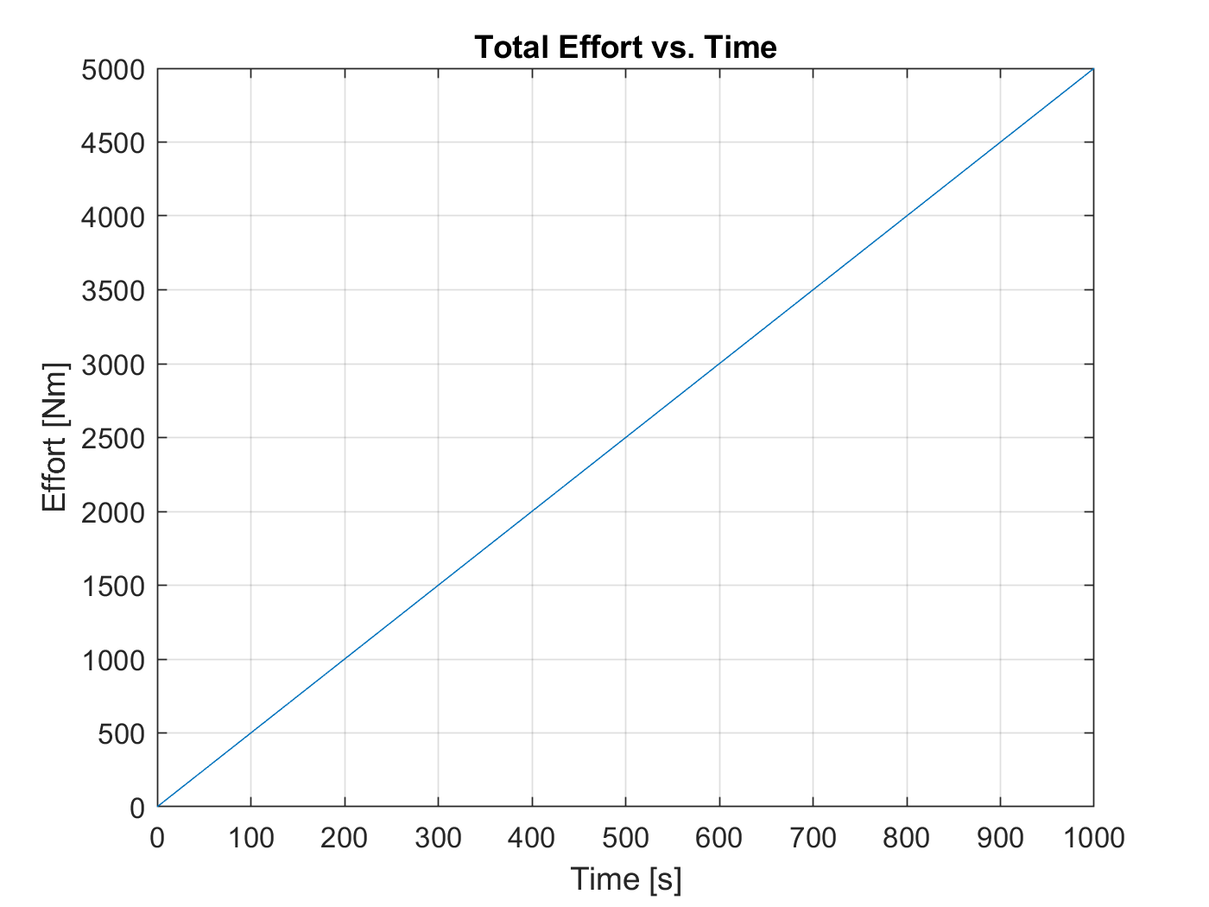

Figure Total Effort vs Time

Deliverables:

* Written Report
  + Describe the problem [x]
  + Describe the strategy [x]
  + Analysis of effectiveness of solution
    - Total control effort
    - Ess
    - Transient response
    - Etc.
  + Design parameters [x]
* Plots
  + Body rates vs time [x]
  + Control effort vs time [x]
* All M-files and Simulink files [x]
* Effort page listing all members and % effort (out of 100%) toward completion of project [x]
  + Must be signed by all members

Effort Report:

Thomas Collins contributed 33%

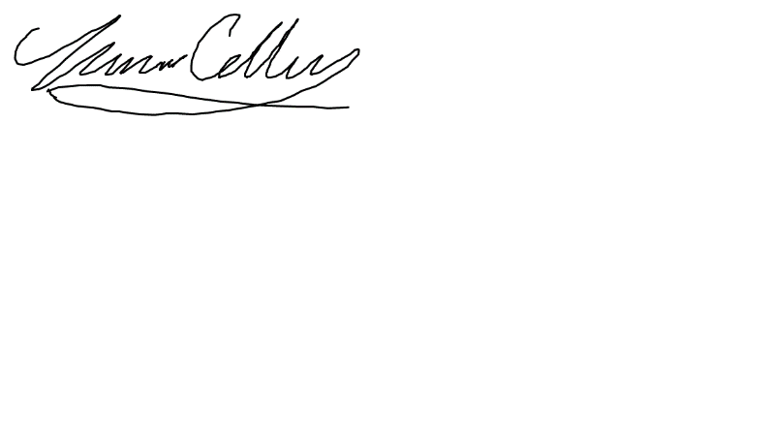



Zachary Raboin contributed 33%



Lucas Simmonds contributed 33%

